TEST CASES PRACTICE
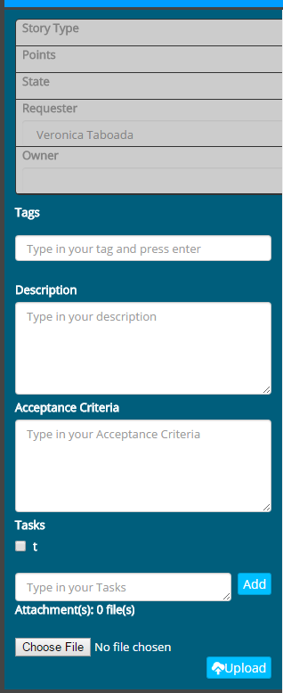

TITLE: | Verify that the option “UE” of the select button “Points” is selected by default.
DESCRIPTION: | Every time that user makes click on the button “+Add Story”, the option “UE” of the select button “Points” is selected by default.
STEPS:
EXPECTED RESULTS: | Option “UE” selected by default.

TITLE: | Verify that the select button “Points” deploy selection options according to the metric estimate
DESCRIPTION: | Every time that user makes click on the select button “Points”, deploy selection options, according to the metric estimate that the project was created.  e.g.
STEPS:
EXPECTED RESULTS: | Options button "lo" deployed according to the metric

TITLE: | Verify that the select button “Points”, don’t contain empty options.
DESCRIPTION: | Every time that user makes click on the select button “Points”, don’t contain empty options.
STEPS:
EXPECTED RESULTS: | Select button "Points" deployed without empty options.

TITLE: | Verify that the select button “Points” is enabled.
DESCRIPTION: | Every time that user makes click on the button “+Add Story”, the select button “Points” is enabled, it means when the user makes click on the select button this can deploy its options.
STEPS:
EXPECTED RESULTS: | Select button "Points" enable.

STATE
TITLE: | Verify that the select button “Points” doesn’t permit select empty options.
DESCRIPTION: | Every time that user selects one empty option, a message of error should be deployed.
STEPS:
EXPECTED RESULTS: | Deploy error message “Don’t permit select empty options”.

TITLE: | Verify that the option “Unstarted” of the select button “State” is selected by default.
DESCRIPTION: | Every time that user makes click on the button “+Add Story”, the option “Unstarted” of the select button “State” is selected by default.
STEPS:
EXPECTED RESULTS: | Option “Unstarted” selected by default.

TITLE: | Verify that the select button “State” is disabled.
DESCRIPTION: | Every time that user makes click on the button “+Add Story”, the select button “Points” is disabled, its means when the user makes click on the select button this cannot deploy our options.
STEPS:
EXPECTED RESULTS: | Select button "State" disabled.

TITLE: | Verify that the select button “State” can be enabled.
DESCRIPTION: | Every time a different "UE" option, of button “Points”, is selected, the button “State” is enabled, it means when the user makes click on the select button this can deploy its options.
STEPS:
EXPECTED RESULTS: | Select button "State” enabled.

TITLE: | Verify that the select button “State” can be enabled.
DESCRIPTION: | Every time a different "UE" option, of button “Points”, is selected, the button “State” is enabled, it means when the user makes click on the select button this can deploy its options.
STEPS:
EXPECTED RESULTS: | Select button "State” enabled.

TITLE: | Verify that the select button “State”, don’t contain empty options.
DESCRIPTION: | Every time that user makes click on the select button “Points”, don’t contain empty options.
STEPS:
EXPECTED RESULTS: | Select button "State" deployed without empty options.

TITLE: | Verify that the select button “State” doesn’t permit select empty options.
DESCRIPTION: | Every time that user selects one empty option, a message of error should be deployed.
STEPS:
EXPECTED RESULTS: | Deploy error message “Don’t permit select empty options”.

Story type
TITLE: | Verify that the option “Feature” of the select button “Story Type” is selected by default.
DESCRIPTION: | Every time that user makes click on the button “+Add Story”, the option “Feature” of the select button “Story Type” is selected by default.
STEPS:
EXPECTED RESULTS: | Option “Feature” selected by default.

TITLE: | Verify that the select button “Story Type” deploy its selection options.
DESCRIPTION: | Every time that user makes click on the select button “Story Type”, deploy selection options
STEPS:
EXPECTED RESULTS: | Options for select button “Feature “deployed .

TITLE: | Verify that the select button “Story Type”, don’t contain empty options.
DESCRIPTION: | Every time that user makes click on the select button “Story Type”, don’t contain empty options.
STEPS:
EXPECTED RESULTS: | Select button “Story Type " deployed without empty options.

TITLE: | Verify that the select button “Story Type” is enabled.
DESCRIPTION: | Every time that user makes click on the button “+Add Story”, the select button “Story Type” is enabled, it means when the user makes click on the select button this can deploy its options.
STEPS:
EXPECTED RESULTS: | Select button "Story Type" enable.

Tags
TITLE: | Verify that the user cannot create empty tags.
DESCRIPTION: | Every time that the user doesn’t put at least one character on field “Tags” and presses enter, a message of error should be deployed.
STEPS:
EXPECTED RESULTS: | Deploy error message “Don’t permit to create empty tags”.

TITLE: | Verify that the user cannot create tags just with blank spaces.
DESCRIPTION: | Every time that the user puts only blank spaces at the field “Tags ”and presses enter, a message of error should be deployed.
STEPS:
EXPECTED RESULTS: | Deploy error message: “Don’t permit to create tags only with blank spaces”.

TITLE: | Verify that the user create tags just with alphanumeric characters.
DESCRIPTION: | Every time that the user puts just alphanumeric characters at the field “Tags ”and presses enter, the tag should be created.
STEPS:
EXPECTED RESULTS: | The Tag created with alphanumeric characters.

TITLE: | Verify that the field “Tags” permits until 12 alphanumeric characters.
DESCRIPTION: | Every time that the user puts until 12 alphanumeric characters. The tag should be created.
STEPS:
EXPECTED RESULTS: | The Tag created with alphanumeric characters.

TITLE: | Verify that the field “Tags” doesn’t permit more 12 alphanumeric characters.
DESCRIPTION: | Every time that the user puts, more than 12 alphanumeric characters on the text field “Tags” , it shouldn't permit put the thirteenth alphanumeric character.
STEPS:
EXPECTED RESULTS: | The text field “Tags” with until 12 alphanumeric characters.

TITLE: | Verify that the text field “Tags” permit to search tags previously created.
DESCRIPTION: | Every time that the user puts at least one alphanumeric character on the text field “Tags” , perform a search of tags previously created by members of project
STEPS:
EXPECTED RESULTS: | Preview of tags found.

